ECO TOYS

In the spirit of environmental protection and in accordance with the vision of eco-kindergarten Vrtec Medvode, our teachers for their children produced eco toys made ​​from natural and waste material.
In this context, the use of material brought up by their parents or have been donated from nearby businesses.
For making various toys teachers use wood, cardboard, plastic, paper, packaging…
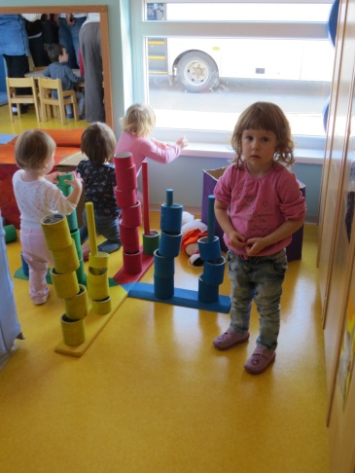
Down below are some pictures with eco – toys, like social game, car, bowling props, learning toys…
