ORIGAMI WORKSHOP
At the 2. Comenius meeting in Slovenia, we organized Origami workshop. We start whith short story about a girl name Maja. »She had a house in a vilage, and she really like her dog and a cat. It was a beautiful sunny day, and on the lawn around the house, grew a lot of colorful flowers.«
Children were able to Origami folding the main »players« in the story. House, dog, cat, sunshine and the colorful flowers. Some folds has been very difficult for them, so luckily our hosts were willing to help them. We all enjoyed it wery much, especially our children, because they really wanted to know our guests.

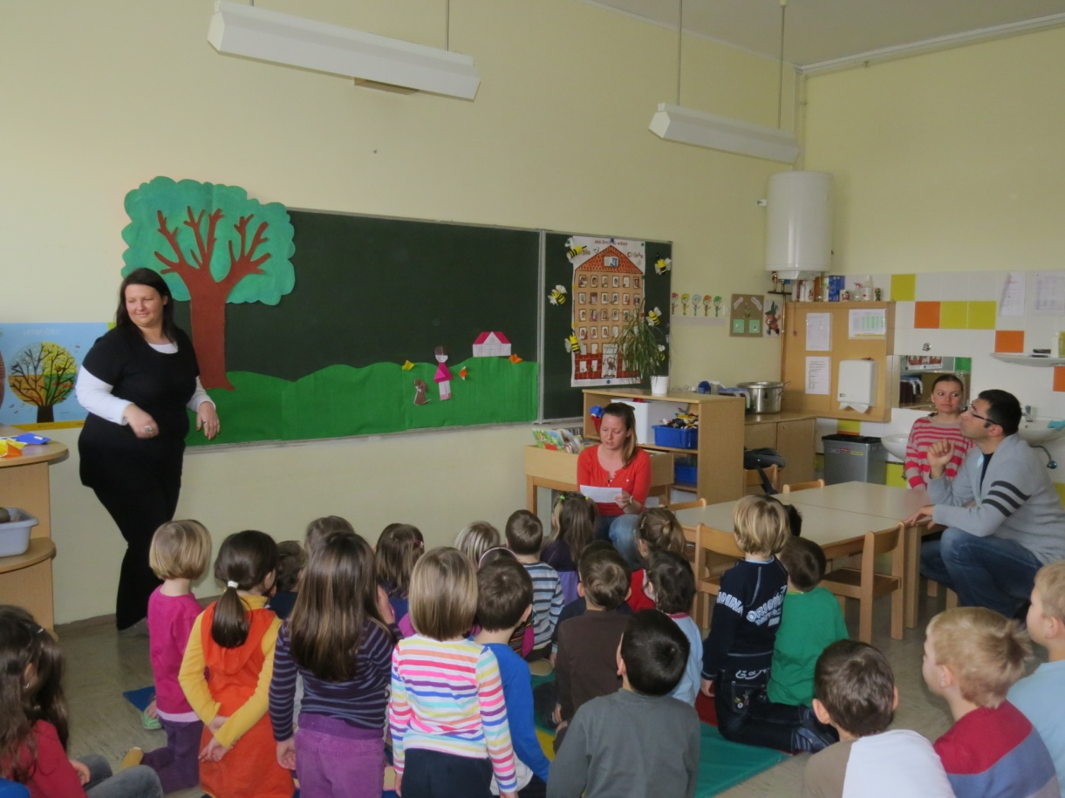
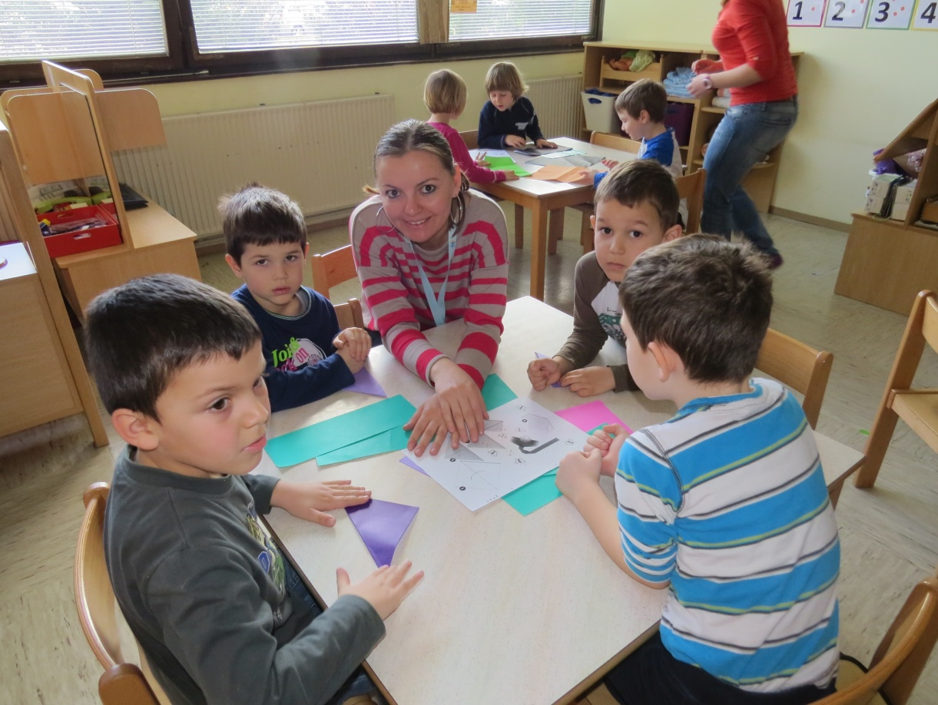
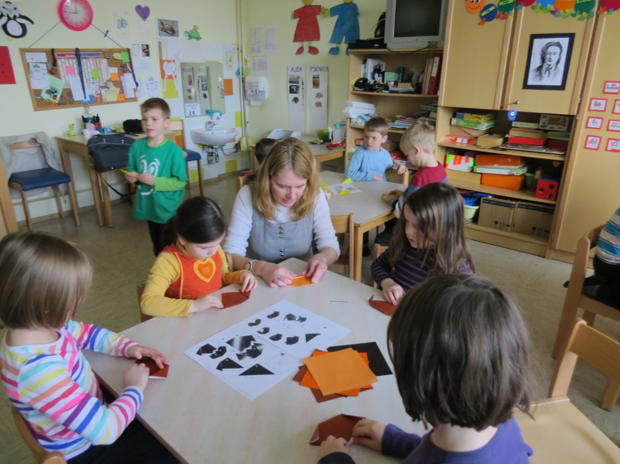
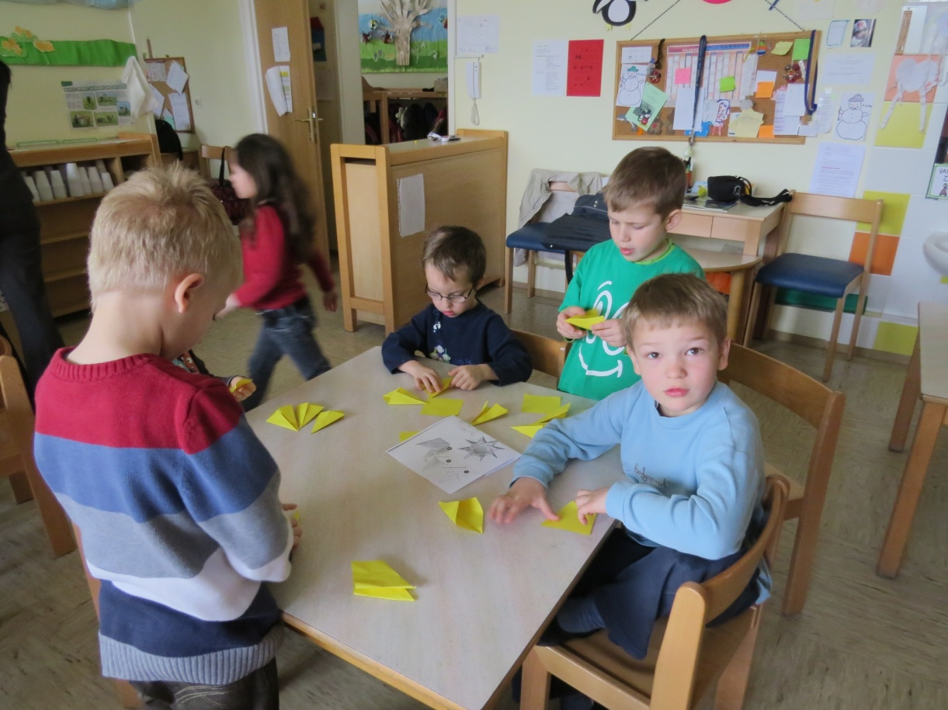
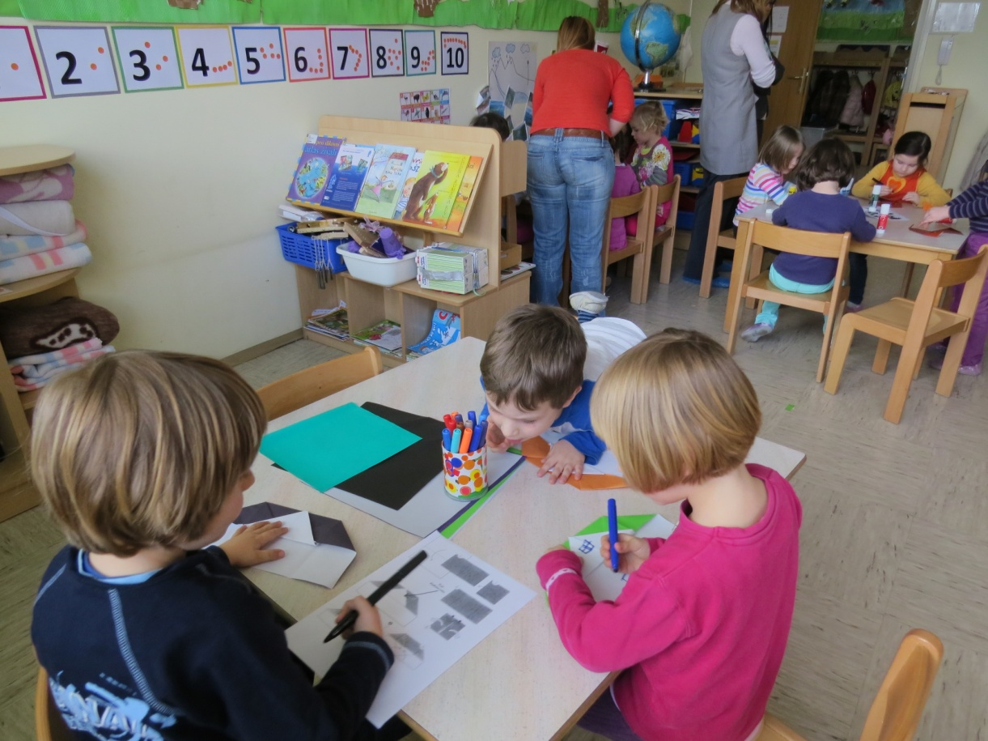
Wrote by Katarina

