Sport program with eco materials - Slovenia
In Pirniče were prepared physical toys from waste material for outdoor exercise.
The bottles were filled with different colors, which were used as pins for stripping the ball.
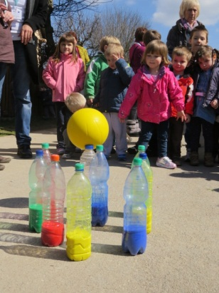
We were prepared baskets from boxes of different shapes - a lion's head, giraffe, clown – and thru openings children are throwing the ball. The large box was cut out openings of various sizes through for throwing balls of different sizes.
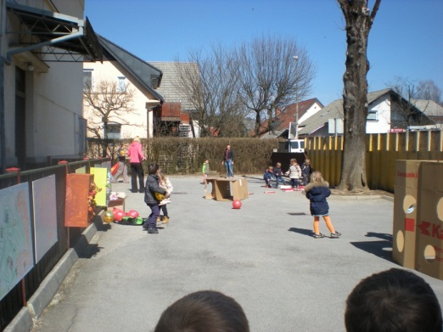
Children were able to crawl through a tunnel out of the box, walk in the footsteps of the box and run around obstacles in the bottle.
.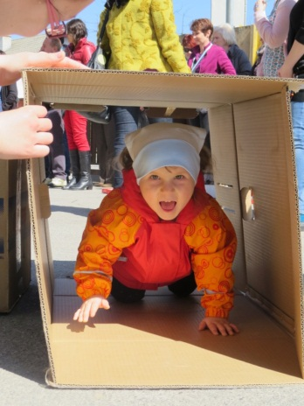
The children were very active and happy for every wall or fallen pins - plastic bottles.
Alenka

